 

INSTITUTE FOR ADVANCED COMPUTING AND SOFTWARE DEVELOPMENT AKURDI, PUNE

Documentation On

**“online Hospital Management system”**

PG-DAC MARCH 2022

**Submitted By:**

**Group No: 44**

**Roll No. Name:**

**223059 Gaurav Mahajan**

**223225 Vaibhav Deshmukh**

**Mr. Prashant Karhale**

**Centre Coordinator Project Guide**

# ABSTRACT

Hospital Management System is an organized computerized system designed and programmed to deal with day-to-day operations and management of the hospital activities. The program can look after Patients records, database treatments, status illness, billings. It also maintains hospital information such as staff, doctors in charge and department administering. The major problem for the patient nowadays to get report after consultation, many hospital managing reports in their system but it's not available to the patient when he / she is outside. In this project we are going to provide the extra facility to store the report in the database and make available from anywhere in the world.

# ACKNOWLEDGEMENT

I take this occasion to thank God, almighty for blessing us with his grace and taking our endeavor to a successful culmination. I extend my sincere and heartfelt thanks to our esteemed guide, **Mrs. Vibhavari mam** for providing me with the right guidance and advice at the crucial juncture sand for showing me the right way. I extend my sincere thanks to our respected **Centre Co-Ordinator Mr. Prashant Karhale**, for allowing us to use the facilities available. I would like to thank the other faculty members also, at this occasion. Last but not the least, I would like to thank my friends and family for the support and encouragement they have given me during the course of our work.

**Gaurav Mahajan (223059)**

**Vaibhav Deshmukh (223225)**

**INDEX**

|  |  |  |
| --- | --- | --- |
| Sr.No | Title | Page.No |
| 1 | INTRODUCTION | 6 |
| 2 | PROBLEM DOMAIN | 7 |
| 3 | SOLUTION DOMAIN | 8 |
| 4 | REQUIREMENT | 9-14 |
|  | 4.1. FUNCTIONAL REQUIREMENTS | 9-12 |
|  | 4.1.1. USE CASE FOR ADMINISTRATOR |  |
|  | 4.1.2. USE CASE FOR PATIENT |  |
|  | 4.1.3. USE CASE FOR RECEPTIONIST |  |
|  | 4.1.4. USE CASE FOR DOCTOR |  |
|  | 4.2. NON FUNCTIONAL REQUIREMENTS | 13-14 |
|  | 4.2.1. USABLILITY REQUIREMENT |  |
| 5 | DESIGN | 15-19 |
|  | 5.1. DATA MODEL |  |
|  | 5.1.1. DATABASE DESIGN |  |
|  | 5.1.2. ER DIAGRAM |  |
|  | 5.2. PROCESS MODEL |  |
|  | 5.2.1. DATA FLOW DIAGRAM FOR LOGIN MODULE |  |
|  | 5.2.2. DESIGN METHODOLOGY |  |
| 6 | MODULES | 20-21 |
| 7 | TESTING | 22-23 |
|  | 7.1. TESTING PHASE |  |
|  | 7.2. TEST REPORT |  |
| 8 | USER INTERFACE | 24-30 |
| 9 | CONCLUSION | 31 |
| 10 | REFERENCE | 32 |
|  |  |  |
|  |  |  |
|  |  |  |

**LIST OF FIGURES**

|  |  |  |
| --- | --- | --- |
| Fig.No | Title | Page.No |
| 4.1.1 | USE CASE FOR ADMINISTRATOR | 9 |
| 4.1.2. | USE CASE FOR PATIENT | 10 |
| 4.1.3. | USE CASE FOR RECEPTIONIST | 11 |
| 4.1.4. | USE CASE FOR DOCTOR | 12 |
| 5.1.2 | ER DIAGRAM | 16 |
| 5.2.1 | DATA FLOW DIAGRAM | 17 |
| 5.2.2. | AGILE DIAGRAM. | 19 |
| 7.1 | LEVELS OF TESTING | 22 |
| 8 | UI | 24-30 |
| 8.1 | HOMEPAGE | 24 |
| 8.2. | LOGIN PAGE | 24 |
| 8.3 | PATIENT SIGNUP PAGE | 25 |
| 8.4 | RESET PASSWORD | 25 |
| 8.5 | PATIENT HOMEPAGE | 26 |
| 8.6 | VIEW APPOINTMENTS | 26 |
| 8.7 | ADMIN HOMEPAGE | 27 |
| 8.8 | VIEW STAFF | 27 |
| 8.9 | ADD PATIENT | 28 |
| 8.10 | RECEPTIONIST HOMEPAGE | 28 |
| 8.11 | ADD STAFF | 29 |
| 8.12 | VIEW DOCTORS | 29 |
| 8.13 | VIEW APPOINTMENTS | 30 |
| 8.14 | VIEW INVOICE | 30 |
|  |  |  |
|  |  |  |

# 1. INTRODUCTION TO PROJECT

A patient is registered to the hospital by filling up a form. The form data is entered into the system by an operator using a graphical user interface. In the interface, there will be some mandatory fields as mentioned in the form. After filling up and submission using the interface, all data will be saved in the database to the corresponding tables. The patient is registered and then he/she will book a appointment to visit a doctor in which a form is to be filled to enter the time slot, date, symptoms and choose a doctor if a patient is not educated enough to use the online services he/she can give a call to the hospital receptionist and register the patient as well as book the appointment in no time. The receptionist will create that patients profile into the database by using interface and if someday the patient want to book appointment online by someone’s help it is possible as well. Then this data is transferred to the allotted doctor and receptionist where the doctor visits the patient and prescribes tests and medicines.

After the treatment is over the patient visits receptionist in the hospital and the billing is done according to the tests, doctor’s fees, prescribed medicines, hospital charges and taxes and a receipt will be printed.

**2. PROBLEM DOMAIN**

‌Till now, using the traditional methods used in the hospitals , the patients had to wait in a long queue and fill up their details and then move to the doctor to have consultation, This process was repeated at every step including the prescribed tests, taking reports, buying medicines, re-consulting the doctor and getting assigned the doctor which makes it a very time-taking and exhausting process for the patients as well as the receptionist to do all the job in a smooth manner, This process exhausted the patient which sometimes lead to hard results. The billing is something which in hospitals is done in bits and pieces and is a problematic situation for families. Sometimes the patients are not so educated to fill the admission forms in the hospital which causes a delay in their admission and may sometimes lead to deprivation from the facilities provided by the government and the hospital.

**3. SOLUTION DOMAIN**

‌The main purpose of this software is that it makes the things easy for the patients as well as their receptionist and the hospital staff. The application provides an online database of the patients to the hospital as well as the patients, which helps in their further treatment.

This will lead to queues getting shorter and dispersing faster as most of the patients can register themselves easily through their mobile phones. And they can be directly assigned the doctor and the doctor can view the patients medical history just by logging in into the patients database. Which can lead to a smoother process and the patient cannot have to wait in long queues and get exhausted as the patient will be assigned a ward directly and the doctor can directly visit the patient into his ward, eliminating the situations of waiting in queues. This will also allow the receptionist and the hospital staff to help the not so educated part of the society, as the people standing in the queues will be less the receptionist can easily help the people who are not introduced to the latest technologies.

The traditional methods in the hospitals used were asking the patients to pay at every step but when the patients database is accessible to the hospital staff. Then the billing can be done at the time of the discharge of the patient not at every single point. Which makes it easier for the patients and their attendants to gather the money at one point not at every point during the treatment.

**4. REQUIREMENTS**

**4.1 FUNCTIONAL REQUIREMENTS**

**4.1.1 Use Case for Administrator**

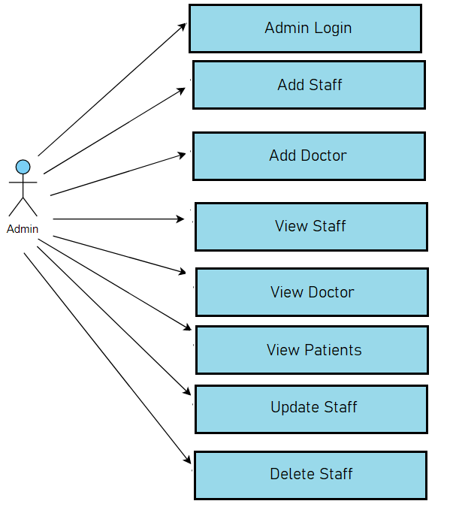

**4.1.2 Use Case for Patient**

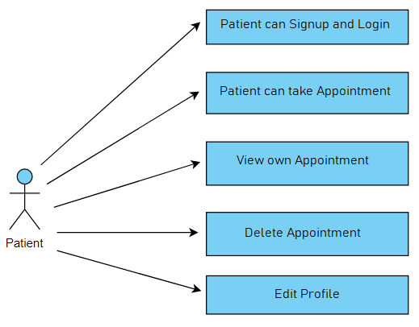

**4.1.3 Use Case for Receptionist.**

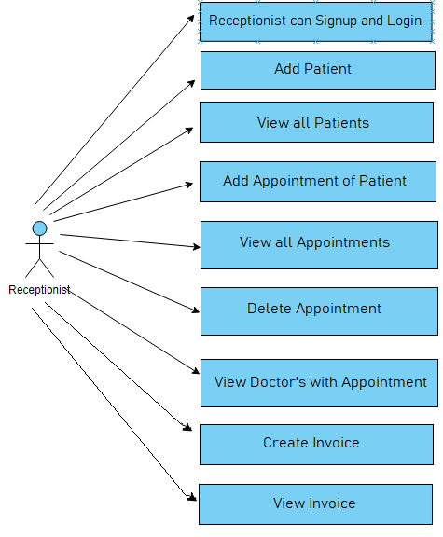

**4.1.4 Use Case for Doctor.**

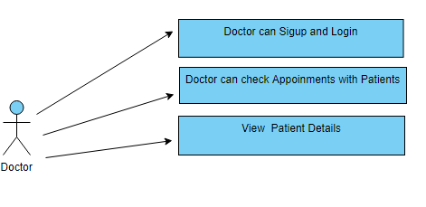

**4.2 NON-FUNCTIONAL REQUIREMENTS**

**4.2.1 Usability Requirement**

**Registration**

Patient can register oneself by filling the signup form or Receptionist can also register Patient while Registration of Receptionist and Doctor is done by Admin only.

**Security**

The complete control of the project is under the hands of authorized person who has the password to access this project and illegal access is not supposed to deal with. Maximum control is under the administrator, then receptionist have control over Patient data as well as appointment details on other hand other members including Doctor and Patient have the rights to just see the records and can edit own profile if any changes happen.

**Session Management:**

We can store user-related information in a session in form of key and value pairs. The HTTP Session interface defines the setAttribute(key, value) method to store a key-value entry and getAttribute(key) method to get value of a specified key.

As user login, user Id is stored in session storage and by using this user Id we can handle individual functionalities and display the data related to particular user.

As user logout from ones respective profile, the Id stored in session storage get deleted automatically.

Due to session management, if anyone tries to access the details of any user directly through then page directly renders to the homepage and by this way we achieved, security with the help of session management.

**Technologies used**

**React:**

React is a declarative, efficient, and flexible JavaScript library for building user interfaces. It lets you compose complex UI’s from small and isolated pieces of code called “components”. React is a JavaScript library for building user interfaces. React is used to build single page applications. React allows us to create reusable UI components.All the front end was completed with the help of React.

**MySQL**

MySQL is a relational database management system based on the Structured Query Language, which is the popular language for accessing and managing the records in the database. MySQL is open-source and free software under the GNU license. All the User's data which is part of Hospital management system is managed with the help of MY-SQL.

**Spring Tool Suite**

Spring Tool Suite is an IDE to develop Spring applications. It is an Eclipse-based development environment. It provides a ready-to-use environment to implement, run, deploy, and debug the application. It validates our application and provides quick fixes for the applications. With the help of Spring tool suite, we created a Spring Boot project from Eclipse and used it for the developing the back end part.

**V S Code**

Visual Studio Code is a streamlined code editor with support for development operations like debugging, task running, and version control. It aims to provide just the tools a developer needs for a quick code-build-debug cycle and leaves more complex workflows to fuller featured IDE’s, such as Visual Studio IDE.With the help of V S Code, we created a react js project and used it for the developing the front end part.

**Git Lab**

GitLab is a web-based Git repository that provides free open and private repositories, issue-following capabilities, and wikis. It is a complete DevOps platform that enables professionals to perform all the tasks in a project—from project planning and source code management to monitoring and security.All the project source code and documentation version control as well as management was done using Git Lab.

**5. DESIGN**

**5.1 Data model -**

**5.1.1 Database Design-**

The following table structures depict the database design.

**Tables-**

|  |  |  |  |  |  |
| --- | --- | --- | --- | --- | --- |
| **Appointment table** | | | | | |
| aid(PK) | adate | atimeslot | asymptoms | pid(FK) | did(FK) |

|  |  |  |  |  |
| --- | --- | --- | --- | --- |
| **Doctor Table** | | | | |
| did(PK) | deducation | dspeciality | dstatus | sid(FK) |

|  |  |  |  |  |  |  |  |
| --- | --- | --- | --- | --- | --- | --- | --- |
| **Invoice Table** | | | | | | | |
| Iid  (PK) | idate | istatus | imedicefees | idoctorfees | ilabtestfees | iotherfees | aid  (FK) |

|  |  |  |  |  |  |  |
| --- | --- | --- | --- | --- | --- | --- |
| **Login Table** | | | | | | |
| id(PK) | email | password | role | pid(FK) | sid(FK) | did(FK) |

|  |  |  |  |  |  |
| --- | --- | --- | --- | --- | --- |
| **Patient Table** | | | | | |
| pid(PK) | pname | pgender | pdob | pphone | paddress |

|  |  |  |  |  |  |
| --- | --- | --- | --- | --- | --- |
| **Staff Table** | | | | | |
| sid(PK) | sname | sphone | sgender | saddress | sdob |

**5.1.2 ER diagram –**

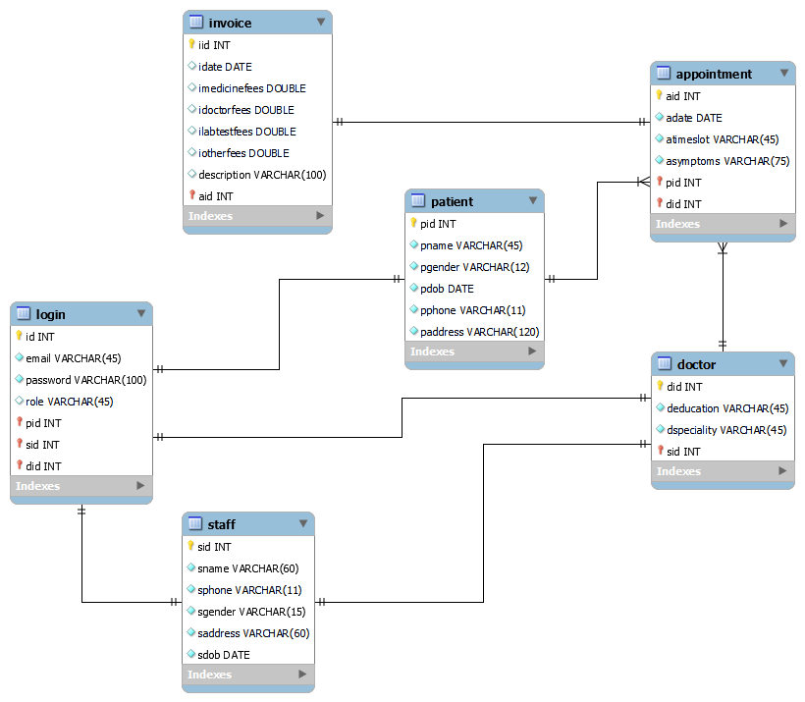

**5.2 Process model -**

**5.2.1 Data flow diagram for login module**

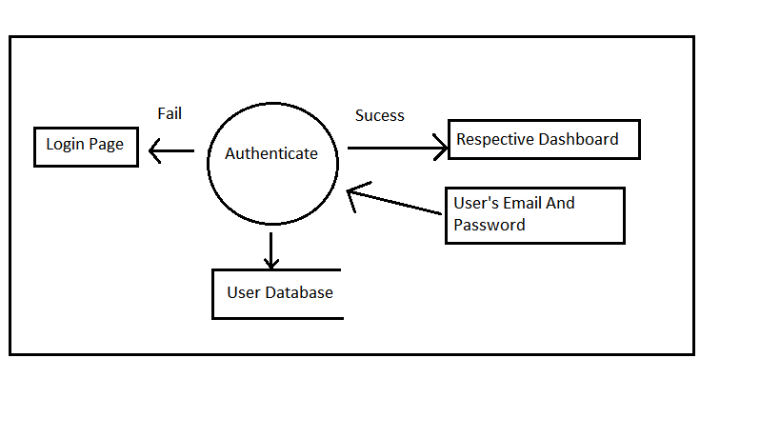

**5.2.2 Design methodology :**

What is a Methodology~~?~~

Software engineering is carried out using preferred procedure techniques to progress the quality of a software development effort. A methodology is defined as a collection of procedures, techniques, tools, and documentation aids which will help developers in their efforts (both product and process related activities) to implement a new system. For successful implementation, a well-organized and systematic approach is crucial. Therefore, several methodologies were developed to encourage the systematic approach to planning, analysis, design, testing and implementation. Methodologies offer various tools and techniques to assist in analysis, design and testing in terms of detailed design of software, data flowcharts and database design.

**Why Methodology?**

1. To complete a project within time and budget with the expected scope and quality we need methodologies which provide for a framework.
2. Most methodologies have a general planning, developing and managing stages in common. They suggest the development team the ways of thinking, learning and arriving at a regular feasible solution.
3. To select an ideal methodology was based on project requirements and goals.

**4.** Functional Decomposition**:** The methodology should have stages according to theinterrelated activities which can be grouped into different functional areas.

**5**. Requirement Changes**:** If required, methodology provides scope to change therequirement.

1. Manage Risks**:** Determined the risk is an important activity to develop a project.

**Documentation: Methodology provides support for large documentation.**

**Analysis and Design Support:** A well-defined structure of the methodology helps foranalysis and designing to development process.

**Implementation:** The system should be implemented as per plan.

**Testing Support:** More testing, more reliable the product is.

**Object Oriented Approach:** Object oriented concepts will be used in developing theproject as it supports component re-usability.

**Suitable Methodologies:**

**Agile development**

Agile software development refers to  software development methodologies centered round the idea of iterative development, where requirements and solutions evolve through collaboration between self-organizing cross-functional teams. The ultimate value in Agile development is that it enables teams to deliver value faster, with greater quality and predictability, and greater aptitude to respond to change. Scrum and Kan-ban are two of the most widely used Agile methodologies. Below are the most frequently asked questions around Agile and Scrum, answered by our experts.

## What is Agile?

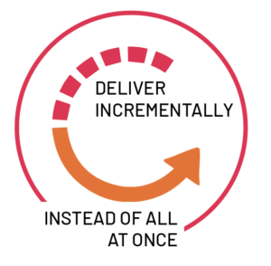

**5.2.1. AGILE DIAGRAM.**

Agile software development refers to a group of software development methodologies based on iterative development, where requirements and solutions evolve through collaboration between self-organizing cross-functional teams. Agile methods or Agile processes generally promote a disciplined project management process that encourages frequent inspection and adaptation, a leadership philosophy that encourages teamwork, self-organization and accountability, a set of engineering best practices intended to allow for rapid delivery of high-quality software, and a business approach that aligns development with customer needs and company goals. Agile development refers to any development process that is aligned with the concepts of the Agile Manifesto. The Manifesto was developed by a group of fourteen leading figures in the software industry, and reflects their experience of what approaches do and do not work for software development. Read more about the Agile Manifesto. Did you know that Agile can also be applied to hardware projects? Learn about C prime's revolutionary Agile for Hardware framework.

6. MODULES

**MODULES USED**

The system comprises of 2 major modules with their sub-modules as follows:

1. **New Staff Registration:**
2. **Staff Login:** User email of the User logging in. here we have provided 3 login UI for admin, doctor and staff.
3. **Password:** The Login Credentials entered by the user to log in.
4. **Home page:** every staff member from (Admin, Doctor, Staff) can visit his/her home page after login.
5. **Admin login:** After login go to admin home page and can view particular Admin details and functions provided for admin such as he can view/update/delete staff and doctor he also can view patient details.
6. **Doctor login:** After login go to doctor home page and can view particular Doctor details and functions provided for doctor such as he can view own appointments and regarding patient details.
7. **Staff login:** After login go to staff home page and can view particular staff details and functions provided for staff such as he can view/update/delete patients appointments and also can view doctor appointment details. Receptionist can add patient and book appointment for patients by selecting doctor. After check-up creating invoice done by receptionist via doctor.
8. **New Patient Registration:**
9. **Registration:** Patient can register his detail.
10. **Login:** Patient Login his account.
11. **Home page:** Patient can visit his home page after login.
12. **Patient Detail:** Can view Patient details by selecting a Patient and view its details such as name, disease, doctor allotted, bill etc…
13. **View/Edit/Delete:** Can view/update/delete the added Patient from the database.
14. **Book Appointment:** Patient can book his/her appointment by selecting a doctor.
15. **View Appointment History:** Can track the Past Appointments by the doctor.
16. **Payment:** The payments will be only on COD basis after invoice generation.
17. **Change Password:** User can change his current password andmake new password.

**7. TESTING**

**7.1 TESTING PHASE**



One of the purposes of the testing is to validate and verify the system. Verification means checking the system to ensure that it is doing what the function is supposed to do and Validation means checking to ensure that system is doing what the user wants it to do.

No program or system design is perfect; communication between the user and the designer is not always complete or clear, and time is usually short. The result is errors and more errors. Theoretically, a newly designed system should have all the pieces in working order, but in reality, each piece works independently. Now is the time to put all the pieces into one system and test it to determine whether it meets the user's requirements. The purpose of system testing is to consider all the likely variations to which it will be subjected and then push the system to its limits. If we implement the system without proper testing then it might cause the problems.

**7.1.1.LEVELS OF TESTING:**

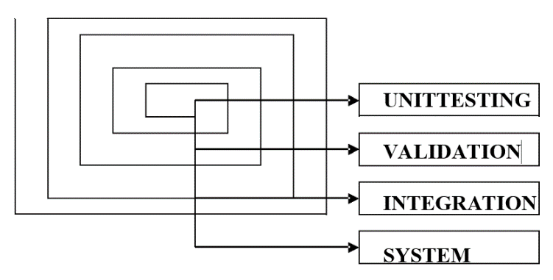

**7.1. TEST REPORT**



**The report of the testing is given here under.**

**GENERAL TESTING**

|  |  |  |  |  |
| --- | --- | --- | --- | --- |
| **SR-NO** | **TEST CASE** | **EXPECTED RESULT** | **ACTUAL RESULT** | **ERROR MESSAGE** |
| 1 | Register Page | Redirected to login page | OK | Nothing |
| 2 | Login Page | Pop-up will come | OK | Invalid credentials |
| 3 | Reset password | Only users password will be reset | OK | Enter valid email |
| 4 | Add appointment | Appointment is added | OK | Nothing |
| 5 | View appointment | Appointments are shown of that patient | OK | Nothing |
| 6 | Edit profile | Edit own profile | OK | Nothing |
| 7 | Add staff | New staff added | OK | Nothing |
| 8 | View staff / patient | All staff / patient list is shown | OK | Nothing |
| 9 | Doctor login | Patients appointed are shown | OK | Nothing |
| 10 | View appointments / delete appointments | Receptionist can add / delete appointment | OK | nothing |
| 11 | Create invoice | Creates invoice with given details | OK | Invoice already created |
| 12 | View invoice | Shows invoice | OK | Create invoice first |

**8. USER INTERFACE**

1. Homepage

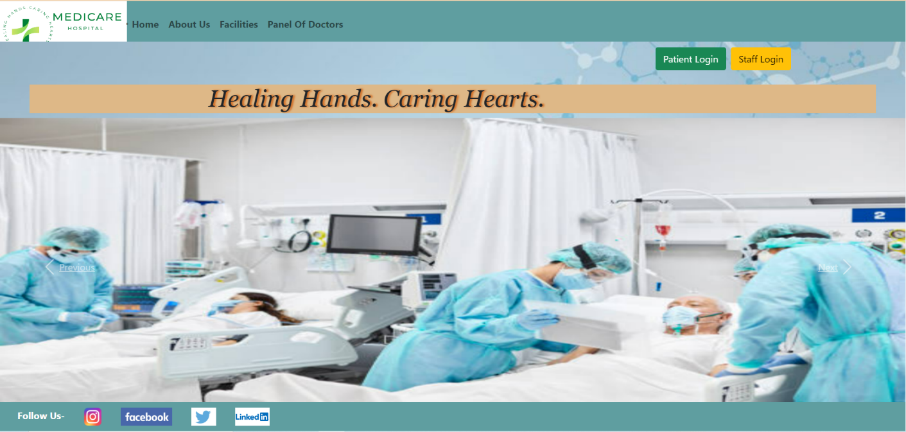

1. Login Page

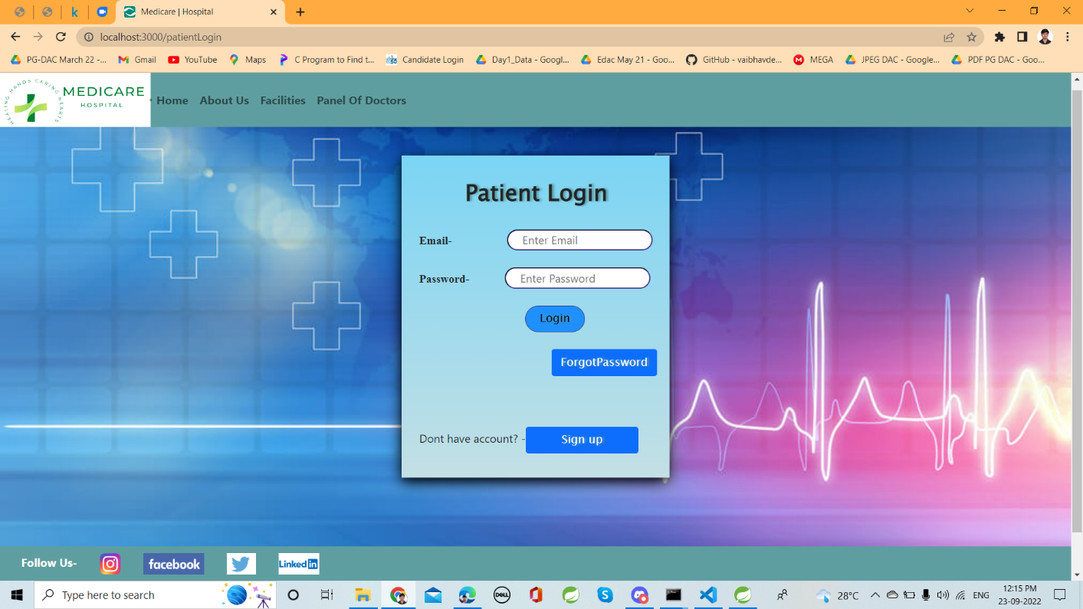

3. Patient sign up page

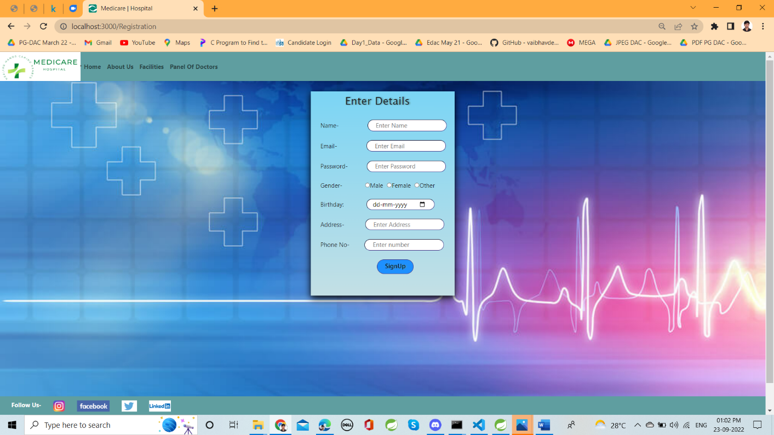

4.Reset password

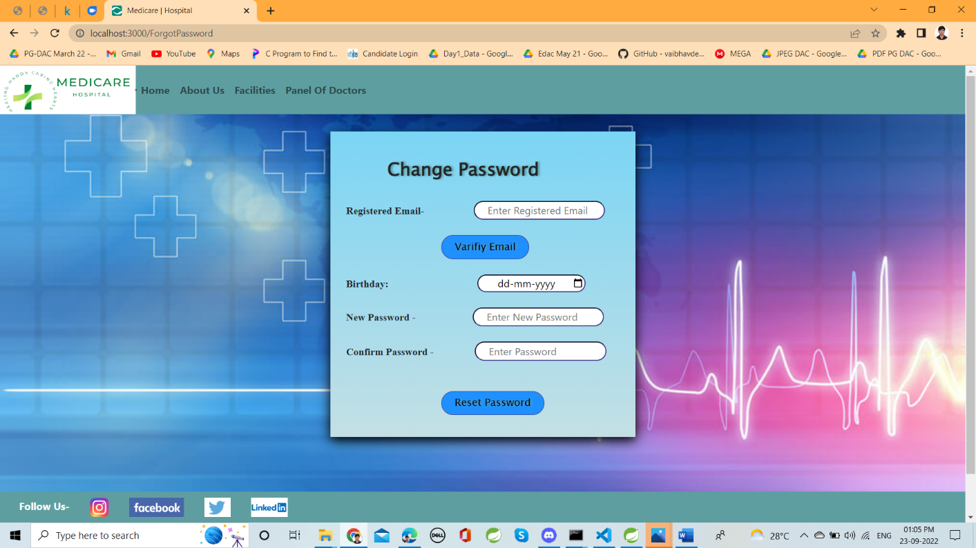

5.Patient homepage

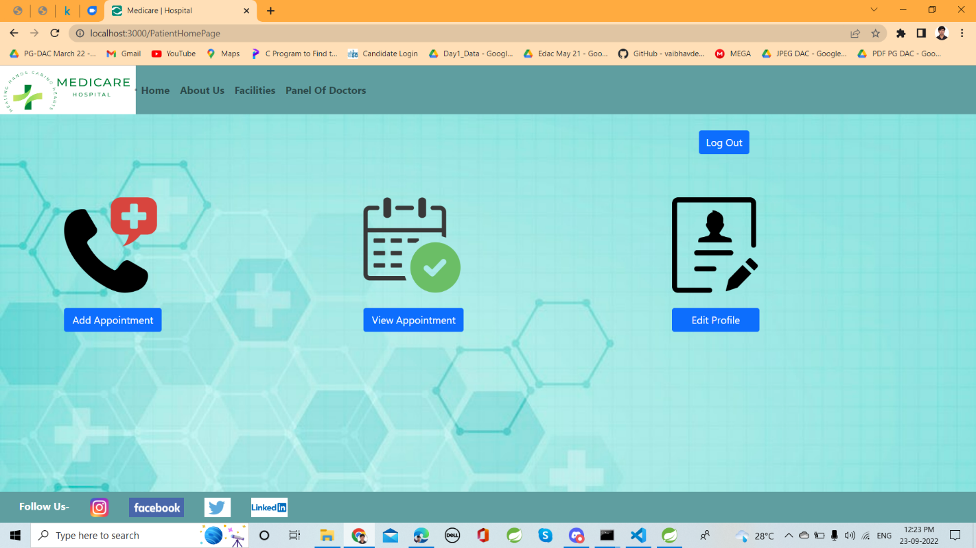

6.View appointments

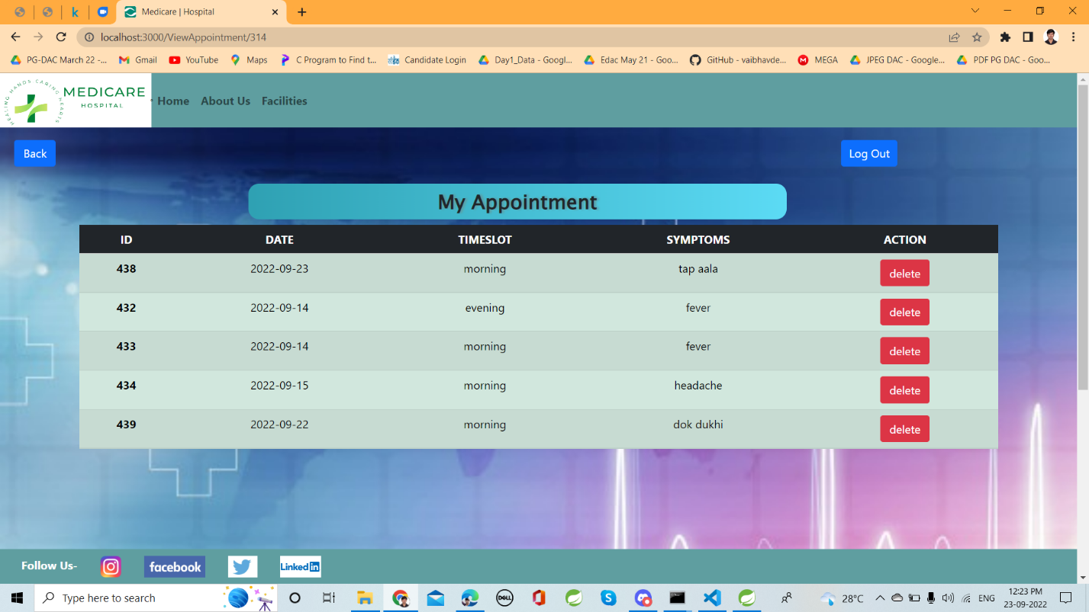

7.Admin homepage

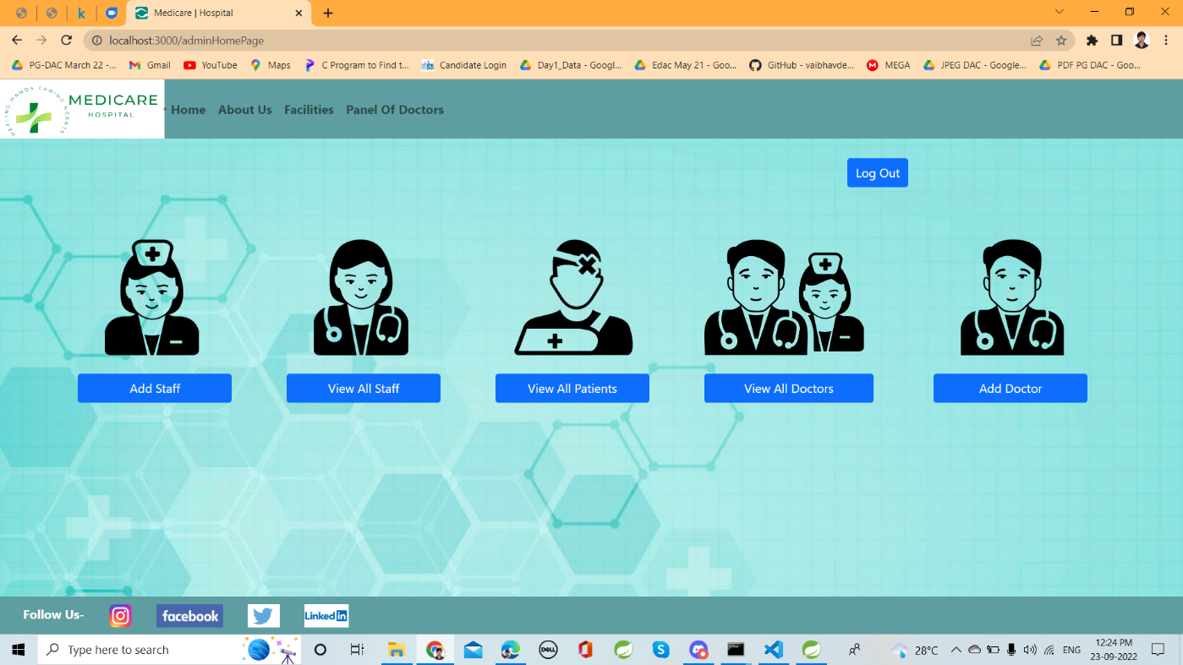

8.View staff

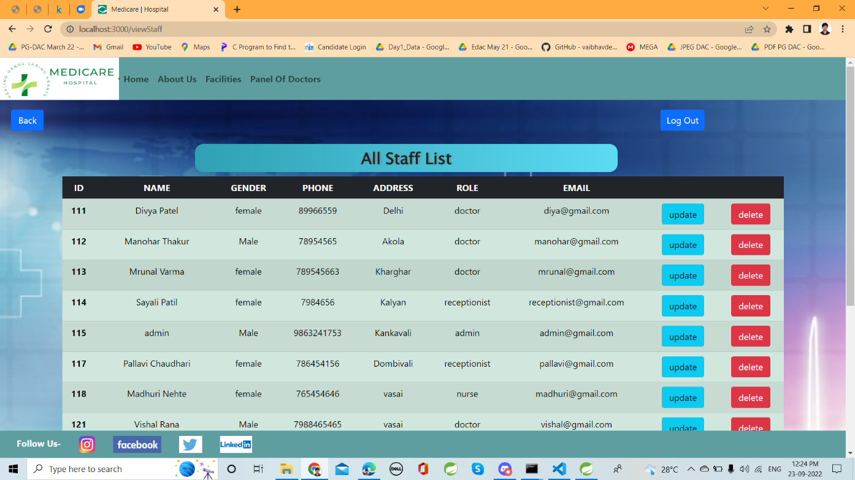

1. Add patient

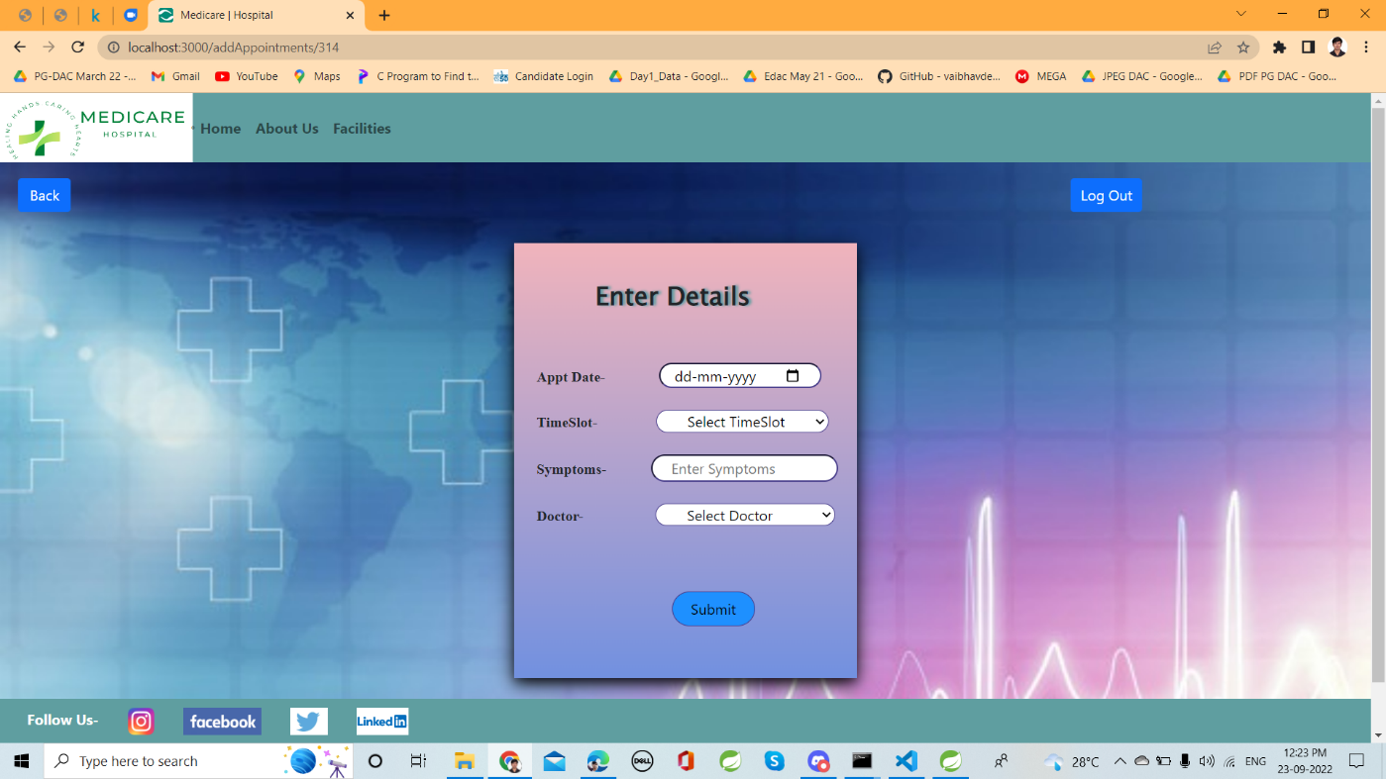

10. Receptionist homepage

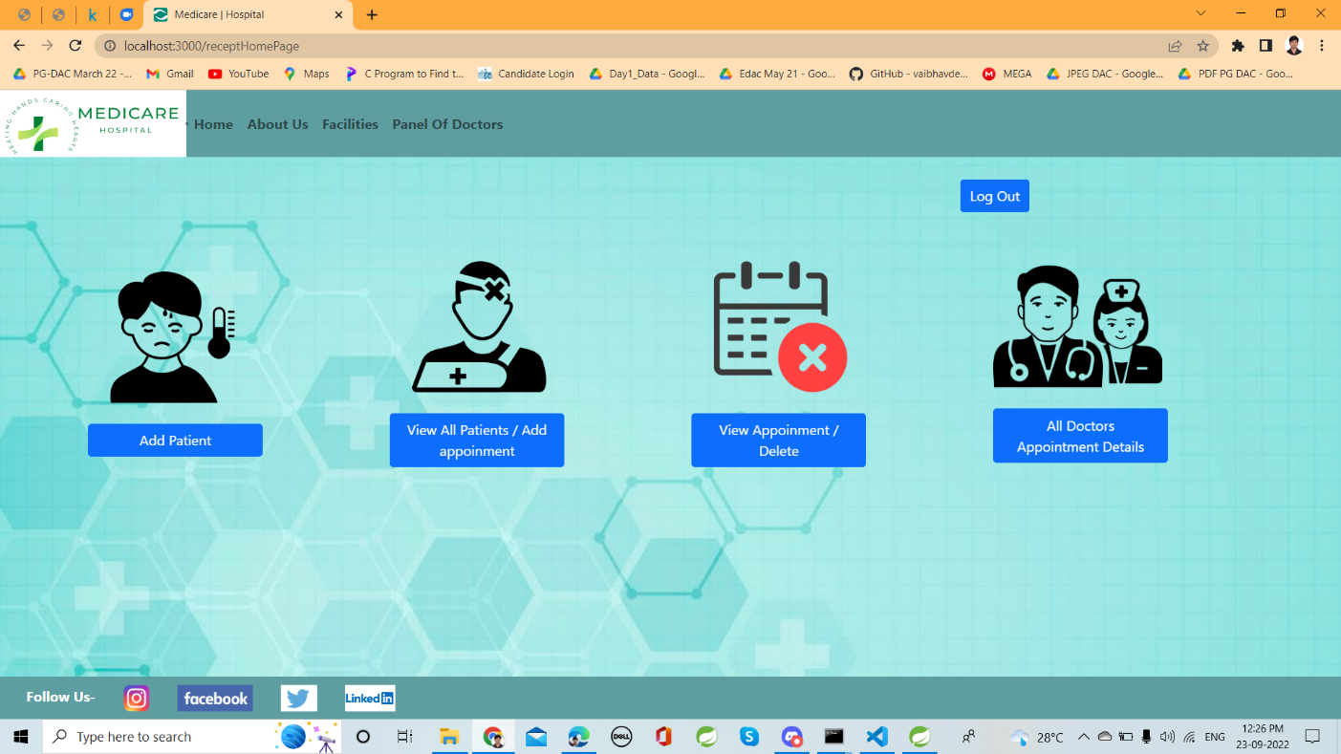

1. Add staff

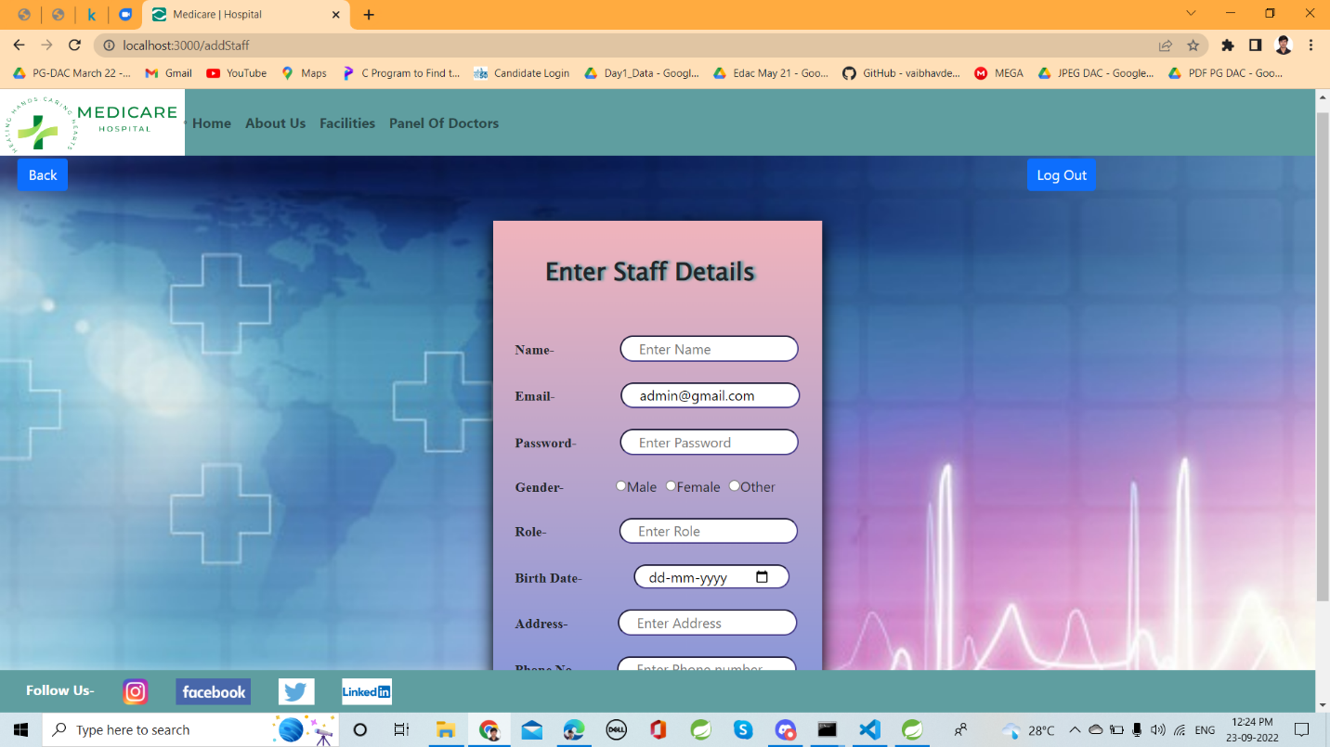

12. View doctors

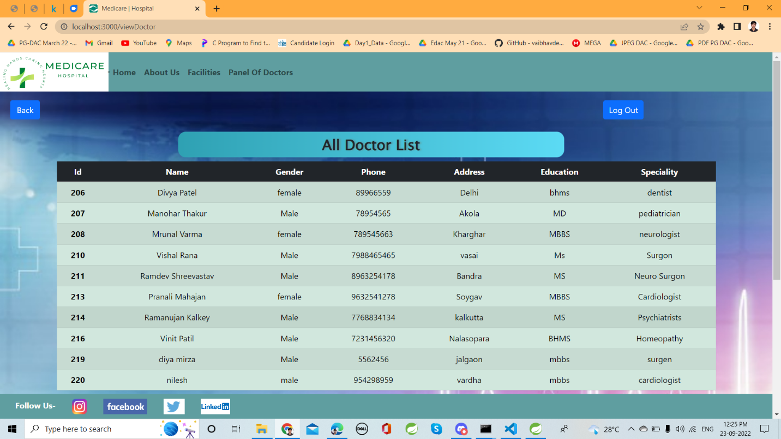

13. View appointments

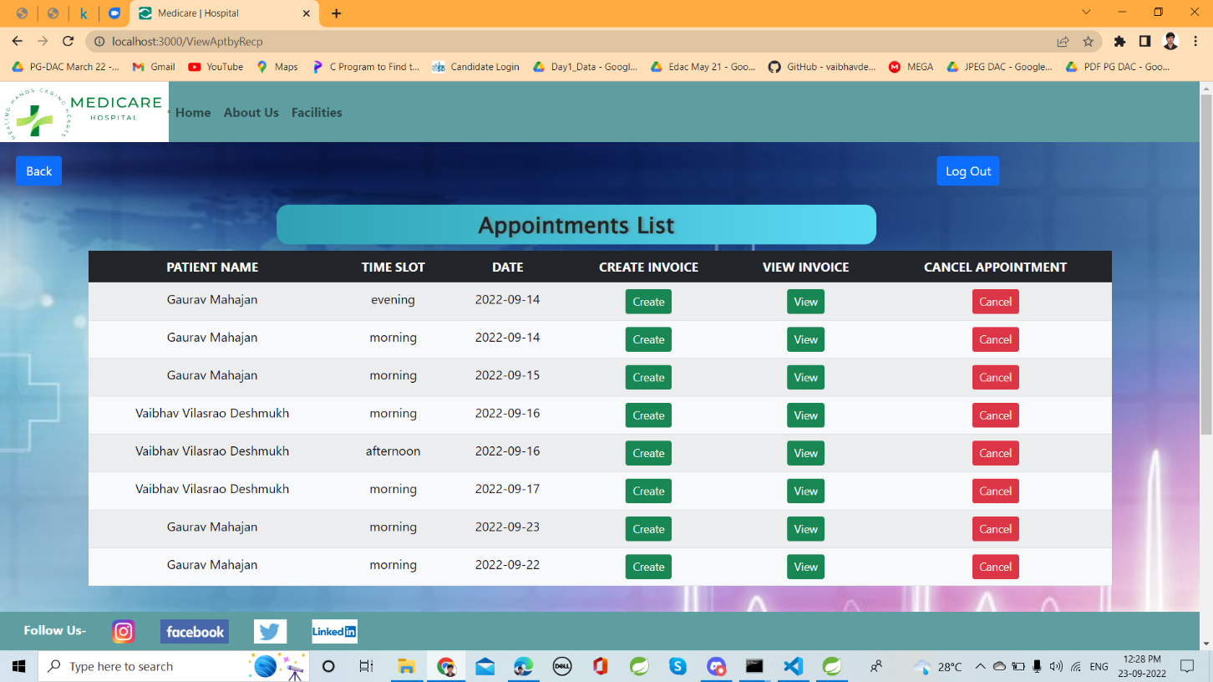

14. View invoice

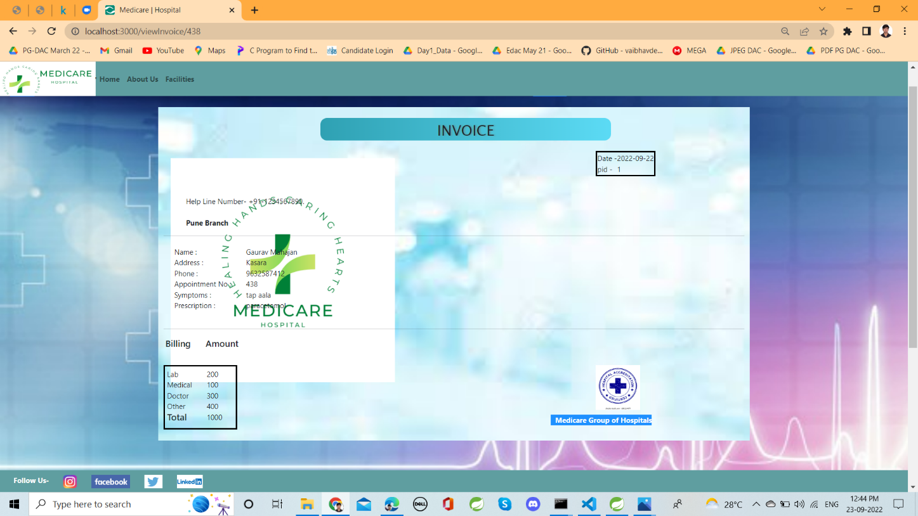

**9. CONCLUSION**

After reviewing our work, the conclusion is that we minimize the efforts of the patients to book an appointment. As we know the current pandemic situation the crowd gathering at the hospitals will be reduced as hospitals are the most critical places to spread the virus.

Our project will help to reduce the crowd contact, the patients are given appointment time slots to visit the hospital and meet the doctor. The doctor can also see the patients visiting and their health profile or symptoms.

We enable the hospital staff and management to securely save the data and fetch the data whenever necessary. The website is user friendly and secure to use. If any patient is not aware of the technology he/she can register their data securely via receptionist.

We give access to 4 kind of users namely admin, receptionist, doctor and patient using email and password which will be verified by the system, in case if any user happen to forget the password we have given the service to change the password after validating the user data.

We have provided static as well as dynamic pages to display data. Every specified user has their our functionalities and in this manner we have tried to achieve contact less appointments according to time slots. Managing staff information and to view information about users and make changes accordingly if necessary.

**10. REFERENCES**

Links:

* <https://getbootstrap.com/docs/5.1/customize>
* <https://www.w3schools.com/css/>
* <https://docs.oracle.com/javase/8/docs/api/>
* <https://stackoverflow.com/>
* <https://javaee.github.io/javaee-spec/javadocs/>
* <https://developer.mozilla.org/en-US/docs/Web/JavaScript>
* <https://hibernate.org/orm/>
* <https://reactjs.org/>